**Evaluating mate encounter and walking dispersal dynamics of termites using posture tracking and behavioral simulation**

**Nobuaki Mizumoto**

Department of Entomology & Plant Pathology, Auburn University, Auburn, AL, 36849, USA

[nzm0095@auburn.edu](mailto:nzm0095@auburn.edu)

ORCID: 0000-0002-6731-8684

**Abstract**

Several termite species are problematic to human society as urban structural pests. Although mature termite colonies with thousands to millions of individuals damage human properties, all these colonies must start from a mating encounter of a female and a male. After seasonal dispersal flights, the termite dealates walk to search for a mating partner and a potential nest site. This very initial phase of the termite colony cycle plays an essential role in dispersal ability, initial infestation, and invasion success; yet, the searching dynamics and success of these walking termites are poorly understood across the environmental factors. In this study, I investigate mate-searching and post-pairing dispersal behavior in *Coptotermes formosanus*, one of the most damaging subterranean termites, by reanalyzing observations in the experimental arena with the deep-learning posture tracking approach. I estimated that termites can walk about 23 m on average and disperse up to 18.74 m on maximum within 15 minutes, with nest-searching tandem pairs expected to disperse more than mate-searching single termites because of the movement coordination. The simulations parameterized by termite observations quantified that urban light attraction greatly contributed to the pairing success of termites, even with the low termite population density. Thus, in the urban context, termites can effectively find a partner near the light, and then tandem coordination helps them disperse from the encounter place. Comparative quantitative behavioral studies across species may predict movement characteristics relating to the invasive and pest status in termite diversity.

**Keywords**

Alate behavior, colony foundation, nest establishment, movement ecology, urban entomology, light pollution, courtship, Formosan subterranean termite

**Introduction**

Among more than 3,000 species of diversity, some termites are serious structural pests, causing damage of $40 billion annually across the world as of 2010 (Rust and Su, 2012). Invasive termite species, especially, have a substantial impact, e.g., *Coptotermes formosanus* is listed as one of the top 10 costliest invasive species (Cuthbert et al., 2022). Termite studies have traditionally focused on the mature colonies, as structural damage to buildings arises only after colonies reach the developed stage (Gordon et al., 2022; Su and Scheffrahn, 1998) (Figure 1). However, even though the mature colony is made up of millions of individuals, all colonies of termites begin with a monogamous mating pair of a female and a male (Nutting, 1969) (Figure 1) with a few exceptions (Perdereau et al., 2015). Such a mate-pairing stage is highly mobile and can be a determinant of initial infestation, population dynamics, and invasion success. Yet, this critical stage has been understudied compared to the mature colonies. In this study, I explore the mate-finding and dispersal dynamics of a termite, *Coptotermes formosanus* Shiraki (Blattodea: Heterotermitidae), especially focusing on their walking behaviors.

In a season of the year, a large number of alates (winged reproductive individuals) fly off from their parental colony nests (Figure 1). There are three immediate tasks for the alates: 1) disperse from their original place, 2) find a mating partner, and 3) find a nest-site to start a colony. This information on *C. formosanus* is well summarized in a chapter of a book on this species (Chouvenc, 2023), where dispersal flight is relatively well-described. The dispersal flight of *C. formosanus* initiates in dusk (late twilight) and continues 15 minutes to an hour (Chouvenc, 2023). Alates of *C. formosanus* show a variable ability to disperse by flight. Direct observation tracked up to 460 m dispersal (Ikehara, 1966), and extensive mark recapture efforts show that they can disperse 621 m on average and up to 1,300 m (Messenger and Mullins, 2005; Mullins et al., 2015), while genotyping alates and surrounding colonies suggests alates dispersed 20-510 m away (Simms and Husseneder, 2009). Collectively, these indicate that alates of *C. formosanus* have a decent ability to disperse and expand their distribution ranges and thus are useful for the distribution surveys. However, as a socially monogamous insect, females and males of *C. formosanus* have to find a partner after dispersion and shedding their wings. Contrary to social Hymenoptera, all important mating processes happen during walking, i.e., finding a mating partner, engaging in pairing courtship, and finding a nest site. Thus, it is essential to quantitatively estimate the dynamics after shedding their wings to evaluate their success after dispersion.

After landing on the ground and shedding their wings, both females and males engage in a mate search by walking. This mate search is assumed to be a random search (Mizumoto and Dobata, 2019), indicating that termites do not know where their partner is until they encounter it, because *C. formosanus* termites do not rely on vision (Mizumoto and Bourguignon, 2022) or long-distance attracting chemicals (Chouvenc et al., 2020; Raina et al., 2003) for locating a partner. Before encountering a partner, both females and males actively move to search for a partner to maximize the searching areas (Mizumoto and Dobata, 2019). Once encountered, a pair of a female and a male performs tandem running behavior, with the leader female and the follower male coordinating motion, while searching for a suitable nest site. In tandem running, a female leader determines the course of the movement (Mizumoto et al., 2021; Valentini et al., 2020), while the follower male maintains contact with his antennae and pulps to maintain the coordination (Mizumoto and Reiter, 2025; Raina et al., 2003). In case of accidental separation between partners, a female leader pauses to wait for the partner, and a male follower engages in a restricted search, which is an effective reunion strategy for the strayed partner (Mizumoto et al., 2020; Mizumoto and Dobata, 2019). Encounters of the same sex may result in tandem runs (Mizumoto et al., 2024a), but it is rarer than other species (Mizumoto et al., 2022). Therefore, on the ground, termites dynamically alternate mate search and nest search until they settle in an available and suitable space for colony foundation (Chouvenc, 2023; Su et al., 1989). These observations provide important behavioral rules used by termite dealates. However, the dispersion-encounter dynamics of dealates remains unknown, e.g., how far termites can travel after shedding their wings or the effective density required for mate searchers to encounter their partner.

In this study, I open this research direction by reanalyzing termite searching strategies studied in a previous study and building a behavioral simulation. Especially, Mizumoto and Dobata 2019 studied the movement patterns of termite dealates in both *Coptotermes formosanus* and *Reticulitermes speratus* to investigate their mate searching strategies. This study obtained the movement trajectories of termite dealates in a petri dish arena, by tracking their body centers with a background subtraction technique, i.e., UMATracker (Yamanaka and Takeuchi, 2018). Since then, more video tracking tools have become available, where there are many advancements in deep-learning-based posture tracking. In this study, by updating the analysis, I reanalyze the same video with one of these advanced tools, i.e., SLEAP (Pereira et al., 2022) to track termite movements by body parts. Then, using posture information, I attempted to unwrap the termite movements in a dish to the approximate open space, to grasp their dispersal abilities by walking. Furthermore, by using the movement parameters of termites, I developed a mate searching simulation and tested the effect of density and urban lights on mating encounter dynamics.

**Figure 1.** Life cycle of subterranean termites, as an example of *Coptotermes formosanus*. In a season of the year, many alates (winged individuals) fly to disperse. After dispersal, females and males look for a mating partner. Encountered pair performs a tandem run to seek a nest site for colony foundation. The established colony grows into the mature colony, which produces alates again. Among these, only mature colonies can damage human property with a large number of colony members.

**Methods**

*Behavioral data*

I used the videos obtained in a previous study (Mizumoto and Dobata, 2019). In this study, experiments with *C. formosanus* were performed to study the adaptive mate search strategy used in termites. Alates were collected using light trapping, or from 2 colonies of *C. formosanus* with nesting wood in Wakayama, Japan, in June 2017. After dispersal flights in the lab, termites that shed their wings were used for the observations. Observations were performed in a Petri dish (Ø = 145 mm) filled with moistened plaster. They observed termites in two different conditions; in single searching experiments, they introduced a female or a male to the experimental arena and recorded their movement for 30 minutes, while in tandem running observations, they introduced one female and one male together to the arena and recorded for 60 minutes. A total of 22 single females, 21 single males, and 20 tandem running pairs were observed.

All videos were analyzed using SLEAP v 1.4.0 (Pereira et al., 2022) to estimate the movement of body parts of each individual. The model was based on that developed for *C. formosanus* in a previous study (Mizumoto and Reiter, 2025), with a 17-node skeleton: antenna tips (LR), antenna middle (LR), antenna base (LR), head (middle of mouth parts), head-pronotum boundary, pronotum-mesonotum boundary, metanotum-abdomen boundary, abdomen-tip, fore legs (LR), mid legs (LR), and hind legs (LR). I only used the data of the head and the abdomen-tip for movement analysis. Due to the video quality, the detection accuracy of legs or antennae was very low, but including these improved the tracking accuracy of the head and abdomen-tips. I trained a U-Net-based model with a multi-animal top-down approach, with a receptive field size of 76 pixels for the centroid and 316 pixels for the centered instance, on Nvidia GeForce RTX 4090, where augmentation is done by rotating images from -180 to 180 degrees. The video analysis was performed for tandem running and single termites separately because of the setup difference between these two experiments, where I finished tandem running first and then used the model developed for tandem running to develop the model for single termites. I labeled 65 frames from 15 videos in tandem running, while 61 frames from 25 videos in single termites. While tracking after the inference, I used the instance similarity method with the greedy matching method. All pose estimation data were converted to HDF5 files for further analysis. I used Python to format all HDF5 files for further analysis and converted them into FEATHER files for analysis in R (R Core Team, 2024). We employed a linear interpolation method to address missing values in the dataset. After scaling all data from pixels to mm, we used a median filter with a kernel size of 5 to reduce noise. All analyses were performed after downsampling at 5 FPS.

From the trajectories, I obtained several kinetic variables as follows. First, I determined the body center as the middle position between the head and the abdomen tip. Displacements of body center positions were computed for every frame to obtain the instantaneous movement speed. The change of the movement speed (acceleration/deceleration) and movement direction were also computed using the displacements. Independent of the movement direction, I also computed termite heading directions as the vector from the abdomen tip to the head. For tandem running observations, we defined tandem running as a state where the distance between the female abdomen tip and the male head is shorter than 3.1 mm (Mizumoto and Reiter, 2025), where short separation or short running (< 1 sec) were smoothed. Then we analyzed movement patterns only during tandem running behavior to compare with single-dealates.

*Unwrapping movements in a dish to open space*

In the dish arena, termite movements are bounded by the arena wall, making it impossible to investigate their dispersal behavior (Nagaya et al., 2017). In this study, however, to grasp the dispersal ability by walking in termite dealates, I converted the movement trajectories recorded in a circular dish into the approximated open-space movements by applying a series of corrections to movements bounded by a constrained space. The conversions addressed two main artifacts: wall-following behavior and mismatches between heading and movement directions caused by the dish walls. Note that these conversions do not completely reflect their motion in the open space; instead, I aimed to approximate how far termites could disperse if there were no boundaries in a dish (Figure S1-3).

First, termites in a dish often exhibit wall-following behavior, moving along the perimeter of the dish in a smooth and curved trajectory (Miramontes et al., 2014; Paiva et al., 2020; Shimoji et al., 2019). I assume that termite movements were biased due to the wall, and termites would maintain their heading direction rather than curving along a dish wall in an open space. Thus, I considered that termites are forced to turn at angles that require them to rotate along the wall. To correct this, I converted the x-y coordinates into polar coordinates relative to the center of the arena. I searched for sequences of frames, where termites moved for more than 10 mm in the same direction of angular coordinates. For each of these events, I obtained how many angles the termite rotated and then adjusted the trajectory by rotating positions to extend the path outward, unwrapping the wall-following sequences (Figure 2A).

Second, near the wall, termite movements are often bounded by the wall, creating many discrepancies between the heading direction (direction from the abdomen tip to the head) and the actual movement direction. I fixed all these discrepancies near the wall (defined as the outer half region in area) by rotating the trajectory around the previous location to align with the heading direction. This assumes that the termite attempts to move forward along its body axis without redirection arising from the dish or tracking artifacts (Figure 2B).

**Figure 2.** Unwrapping trajectories in a dish to open space. (A) Correction of the wall-bound rotating motions. The path circulating around the dish was unwrapped by rotating positions to extend the path outward. (B) Fixing the discrepancy between heading directions and movement directions. Using posture tracking datasets, the movement directions were replaced by heading directions to mimic the movements in an open space.

*Statistical analysis*

I used a series of linear mixed models (LMMs) to compare the speed, change of speed (acceleration/deceleration), and turning patterns, using R functions lmer() in the package ‘lme4’ (Bates and Maechler, 2015) and lme() in ‘nlme’ (Pinheiro, 2011). I used the likelihood ratio (type II) test to examine the statistical significance of each explanatory variable. First, I investigated the relationship between instantaneous speed and speed change in the next moment, using an LMM, where speed change was the objective variable, while speed, single or tandem leader (hereafter units in this section), and their interaction were fixed variables. The video ID that is nested within the original colony was included as a random effect (random intercept). Second, I compared the instantaneous speed between units using a similar LMM with instantaneous speed as the objective variable, units as fixed variables, and the video ID nested within the original colony as a random intercept. In addition, to compare whether the variability in these parameters differed between units, I fit two LMMs: the first included only random intercepts (the video ID that is nested within the original colony), and the second assumed that the variance could be variable between units in addition to the random effect. The fittings of these two models were compared using the likelihood ratio test. I also compared the traveled distance between units using an LMM with traveled distance as the objective variable, units as fixed variables, and colony as a random effect. The traveled distance was obtained by computing the mean step length per 0.2 seconds and summing up for 15 minutes for the aid of interpretation.

Next, I investigated the dispersal patterns of the trajectories unwrapped from the bounded space to the open space. As for tandem running observations, I focused on each tandem running event rather than each video, as the latter included both tandem running and separations. First, for each trajectory, I extracted how far termites dispersed at 15-minute time points and compared them between units using a similar LMM as above. I also computed the mean squared displacement (MSD) to investigate the diffusive properties of the unwrapped trajectories. The MSD is the mean of the squared distance that an organism travels from its starting location to another point during a given delay time, τ. The MSD is proportional to the time to the power of α, MSD ~ τα, where α characterizes the behavior of diffusive processes. In normal diffusion, as is the case with Brownian motion, the MSD increases linearly with time (α = 1), while α < 1 indicates subdiffusive and α > 1 indicates superdiffusive processes. MSDs were obtained in the entire range of each trajectory, using the function computeMSD() in the package ‘flowcatchR’ (Marini, 2017). Then, to obtain the diffusion properties, I examined the relationship between MSD and τ using a log-log transformation. Fitting was restricted to a subset of datasets (0.2, 0.4, 0.6, 0.8, 1, 2, 4, 6, …, 1000) to avoid the oversampling at the larger τ. The fitting was performed by an LMM with each trajectory identity included as a random slope. The slope α obtained from this regression corresponds to the scaling exponent, which characterizes the diffusion regime (e.g., subdiffusive, diffusive, or superdiffusive).

**Results**

In both single dealates and tandem leaders, moving speed and change in speed were obviously correlated, where termites speed up after the slower movements, while they slow down after the fast movements (Figure 3AB). The slopes of the response regressions were different between singles and leaders (LMM, interaction: χ21 = 28.18, *P* < 0.001), with singles changing their speed more sensitively than tandem leaders (slope, single: -0.184, leader: -0.176). There was no difference in mean speed between singles and leaders (LMM, χ21 = 1.2, *P* = 0.273). However, the data distributions clearly showed that both speed and change in speed are more variable (wider distribution) in single dealates than tandem leaders (Figure 3AB). When comparing the models with and without variability between single and leaders, the model allowing different variances provided a much better fit to the data, with leader speed being less variable than single dealate speed (χ21 = 17010.06, *P* < 0.001). The same was true for the change in speed (χ21 = 21499.91, *P* < 0.001).

Similarly, turning patterns also differ between single dealates and tandem leaders. Again, data distribution clearly showed the wider distribution in single dealates compared to tandem leaders (Figure 3CD), which is supported by comparing models with and without variable variance of angles between singles and leaders (χ21 = 27673.09, *P* < 0.001). Also, interestingly, the relationship between instantaneous speed and turning was different between single dealates and tandem leaders. In single dealates, turning angles became more variable according to the movement speed (Figure 3C). On the other hand, tandem leaders decreased turning angles when they are constantly moving (S.D. of turning angles achieved a local minimum around 3.8 mm/0.2sec, Figure 3D).

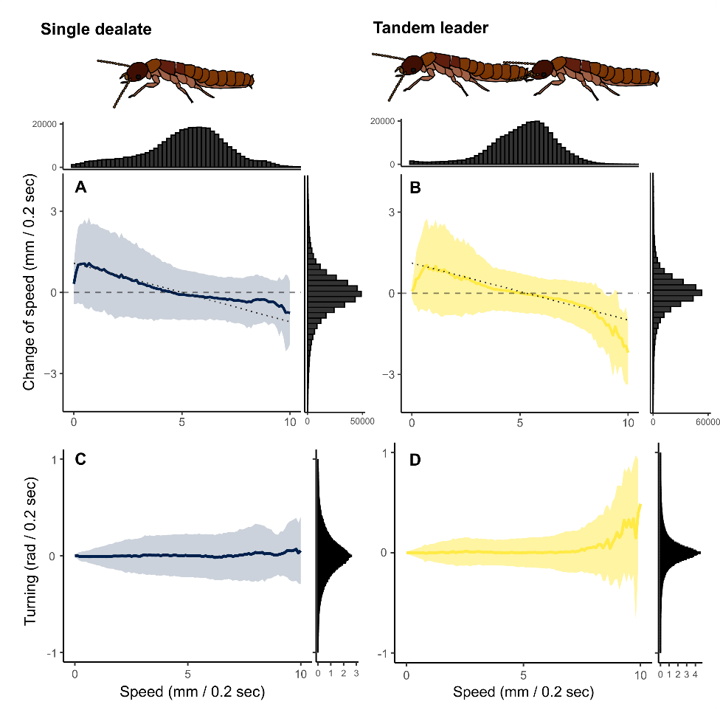

**Figure 3.** Movement parameters for termite dealates. The lines and colored area indicate the Mean ± S.D., which was calculated by binning the speed by 0.1. For the change of speed (acceleration/deceleration), the dashed regression lines by LMM were drawn. The histogram of each kinetic parameter was also shown.

During the observations, termites kept moving on the petri-dish arena despite the bounded space. There was no significant difference in traveled distance between single dealates and tandem leaders (χ22 = 1.52, *P* = 0.469, Figure 4A). Notably, termites walked about 23 ± 4.2 m (mean ± S.D.) in 15 minutes on average. The unwrapping procedure extended the movement trajectories to an open space (Figure 4CD, Figures S1-3). Within the first 15 minutes, tandem running dispersed further distances than single individuals (χ21 = 5.03, *P* = 0.025, Figure 4B), where, on average, single individuals dispersed 6.5 ± 3.7 m from the starting point, while the tandem leader dispersed 9.6 ± 4.8 m.

The MSD showed that tandem leader movements were more diffusive than single termites (Figure 4CD). The diffusive exponent α was estimated to be 1.65 (with S.D. of 0.12 by the random slope, LMM) for single termites, while 1.80 (with S.D. of 0.12 by the random slope, LMM) in tandem leaders. In either case, the trajectories showed the superdiffusive properties as observed in arthropods in (pseudo-) open spaces (Johnson et al., 1992; Mizumoto et al., 2024b; Nagaya et al., 2017; Seuront and Stanley, 2014).

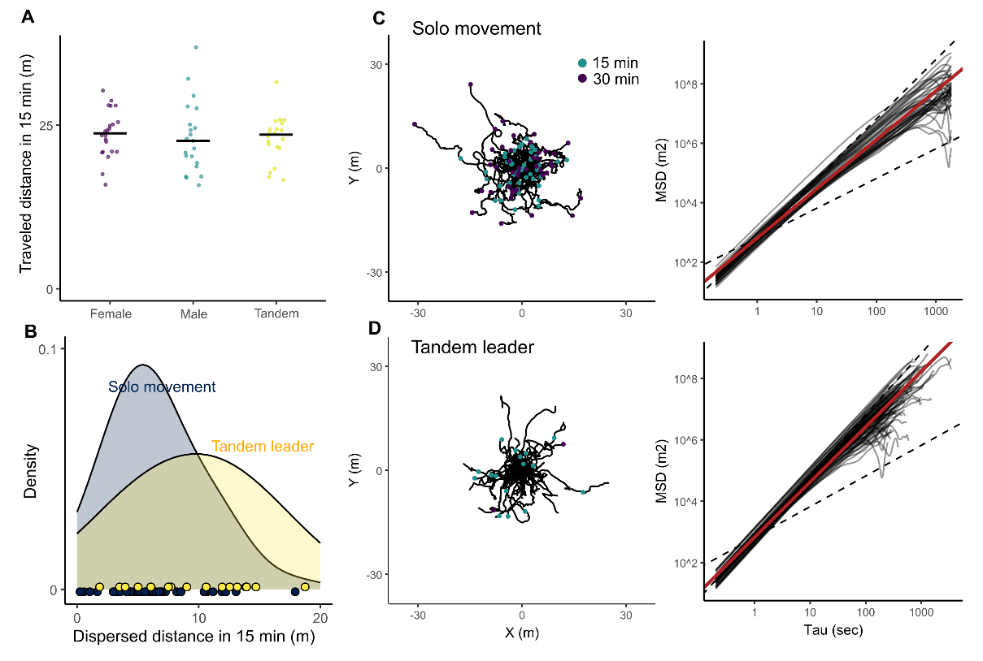

**Figure 4.** Dispersion patterns of termite dealates. (A) The comparison of traveled distance between different dealate units. The traveled distance for 15 minutes was obtained from the mean traveled distance in 0.2 seconds for each individual. (B) The distribution of dispersed distances from the starting point after 15 minutes in the unwrapped trajectories. Unwrapped trajectories and mean square displacements in (C) single individuals and (D) tandem leaders. Red regression lines are generated using LMM. Data of females and males are pooled in (B-C).

**Simulations**

I used an individual-based model to examine the mating encounter dynamics of termites with the estimated movements in the open space. Termites search for a mating partner in a periodic boundary condition of size *L*area x *L*area. There are two different scenarios for mate search (Figure 5A): i) without light, where all individuals are randomly located in the area, ii) with light, where all individuals are attracted by light before shedding their wings, and thus start from the concentrated area with size *L*light x *L*light. In each condition, females and males walked until they encountered another individual of the opposite sex. When the distance between the centers of a female and a male became smaller than φ (= 10 mm), they were regarded as having encountered (Mizumoto and Dobata, 2019).

Individuals perform correlated random walks in terms of both speed and turning angles. The current individual movement speed is correlated with the previous speed as the acceleration correlates with the speed (Figure 3), which is determined as follows:

,

where parameter values were obtained by fitting the empirical datasets of solo individuals, a = -0.184, b = 0.910, σ = 0.628. Turning angles also followed a Laplace distribution with scale parameter σ = 0.164. I used Laplace distribution instead of common angular distributions, such as wrapped Cauchy or von Mises distributions, because the distribution of empirically observed turning angles was skewed towards the center (Figure 3), where the Laplace distribution showed a better fit than others.

In the simulation, one timestep corresponds to 0.2 seconds, consistent with the frequency of data analysis of 5 FPS. The simulation lasted for 30 minutes (9,000 steps), and the number of pairs produced was recorded for every frame. I set the initial number of individuals as 100, 1,000, and 10,000, corresponding to small, middle, and large swarming events (Chouvenc et al., 2017; Higa and Tamashiro, 1983; Sugio, 2019). The whole area size *L*area was 30 m, and the alates are attracted to the area with *L*light = 3 m. The simulation program was implemented in C++ as functions and executed in R, using a package Rcpp (Eddelbuettel and Balamuta, 2018). The results of the sensitivity analysis of these parameters are in the supplementary materials (Figure S4).

The simulation results clearly showed the Allee effects on the termite mating encounters as observed in a termite (Kusaka and Matsuura, 2017). In higher density conditions, more termites could encounter a mating partner, and light trapping greatly increased the mating encounter probability by increasing the local termite densities (Figure 5B, S4). With the empirically observed walking abilities of *C. formosanus*, 100 randomly located termites in a 30x30 m area are desperate to find a mating partner only by random search. However, with increased density, dealates of *C. formosanus* could find a partner sufficiently only through random search. On the other hand, even with a limited number of termites available in the population (e.g., 100), light trapping can increase the local density and result in a higher encounter probability than the condition without light but with a larger population (Figure 5).

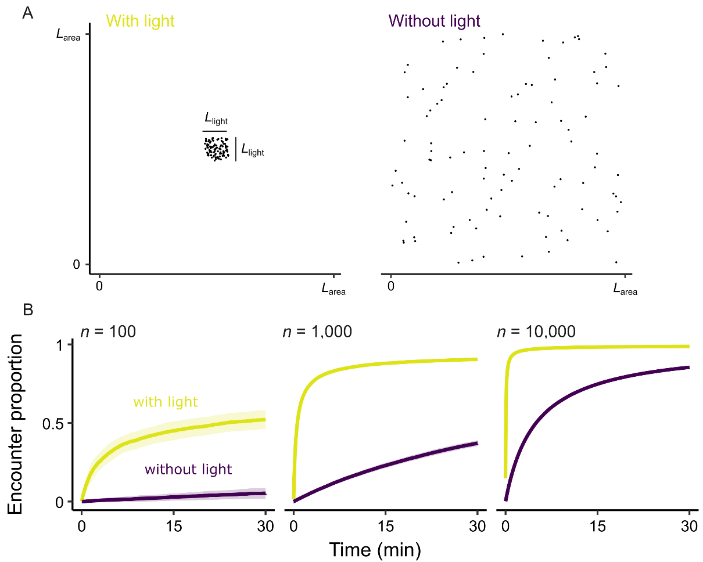

**Figure 5.** Termite movement simulations. (A) Two different initial searching conditions. Without light, termites are located randomly across the entire area, while with light, termites are located in a specific area. In both situations, the area of *L*area x *L*area is a periodic boundary condition. (B) The results of the simulation with *L*area = 30 m and *L*light = 3 m. See Figure S4 for other parameter combinations.

**Discussion**

In termite dealates, walking to search for a mating partner and a suitable nest site is an essential first task after dispersal. The comparison shows that the movement of tandem running pairs (nest site searching) is more diffusive and more stable than the movement of single termites (mate searching). The moving speed of tandem leaders is less variable than that of single termites, and the turning angles are also less variable (Figure 3). Such a stable and more straight motion by tandem leaders resulted in dispersing more distances from the initial points, even though the total travel distance was not different from single termites (Figure 4). This difference between single termites and tandem leaders makes sense from both ultimate and proximate points of view. Ultimately, a more dispersed motion of tandem running leaders allows them to get apart from the place where they encountered. Mate searching behavior is mutual search, where both females and males search for each other, and even slow-moving or pausing behavior can achieve a higher encounter rate for one sex (Foffi et al., 2025; Mizumoto et al., 2017; Mizumoto and Dobata, 2018; Reynolds, 2006). On the other hand, in nest-site search, the advantage of moving a greater distance will be higher than in mate search, as the nest-site does not move to find a site searcher. Furthermore, if termite mate searchers are clumped in one location, dispersing from there may be advantageous, as encountering another mate searcher can lead to the interruption of tandem running (Mizumoto et al., 2020).

Proximately, more stable and straight motion of tandem running may be the consequence of movement coordination. In tandem running behaviors, leaders and followers coordinate their motion. Especially, leaders slow down and followers speed up with more distance between partners, while leaders speed up and followers slow down with less distance (Mizumoto and Bourguignon, 2022; Mizumoto and Reiter, 2025; Valentini et al., 2020), where similar speed controls can be observed in ant tandem running (Franks and Richardson, 2006) or different types of movement coordination (e.g., fish (Schaerf et al., 2021)). Also, to maintain contact between leaders and followers, the possible movement directions of leaders may have been limited compared to when they are alone, because sharp turns by leaders often result in the interruption of tandem running (Mizumoto et al., 2020; Valentini et al., 2020). In this sense, even though tandem running is a simple movement coordination, cooperation between partners can, in turn, affect the pair-level movement patterns.

Artificial light, especially in urban areas, is generally harmful to nocturnal flying insects (Owens et al., 2020), e.g., by trapping insects near the light source for a long period and eliminating the time window for other essential activities (Kasai and Hironaka, 2024). However, *C. formosanus* termites (and several other species) could be in a unique position that can use artificial light in a beneficial way, because termites change their response to the light in a short time frame. With wings, alates are attracted by lights as in other nocturnal insects, but once they shed their wings near the light source, dealates turn to show negative phototaxis (Chouvenc, 2023; Ferreira and Scheffrahn, 2011; Ohmura et al., 2014). Thus, termites will not be trapped by light for a long period, and their tandem running behavior is not affected by light (Mizumoto and Bourguignon, 2022). Previous studies suggest that urban lights should have contributed to their successful invasion processes (Chouvenc, 2025), which is indirectly supported by the fact that the diurnal flight species, *C. testaceus*, is not as invasive as *C. formosanus* or *C. gestroi* (Scheffrahn et al., 2015). The simulation also quantitatively support this idea by demonstrating that *C. formosanus* can enjoy the benefits of urban light, with empirically observed walking abilities of termites (Figure 5 S4), e.g., 100 termites / 30x30 m2 is too low density for termites to find a partner through random search, but light traps can inflate the encounter rate more than the level of 10 times density in the same area. This can make even the small swarming events fruitful for termites (Chouvenc et al., 2017; Higa and Tamashiro, 1983; Sugio, 2019), as well as the nest establishment in the invasion frontier, which is usually limited by the population size, promising.

Note that the unwrapping method used in this study is not a perfect approximation of the movement in an open space, but the aim is to grasp the dispersal ability of *C. formosanus* termites by walking. The unwrapped trajectories still have several artifacts. For example, termites sometimes show 180° turns while following the wall. This can be interpreted that termites try to turn in some direction but are bounded by the wall, resulting in 180°. It is impossible to know the termite's intention; thus, these turns appear as sharp directional changes in the unwrapped trajectories (Figures S1-3). Also, the wall itself could affect the behavior of insects (Scharf et al., 2024). However, except for several artifacts, I consider that the effect of bounded space on termite behaviors is minimal, especially in mate-or nest-searching termite dealates. Different from other solitary insects, the time for termites to search for a partner or nest is very short, i.e., up to a few hours (Chouvenc, 2023) or until they die (Mizumoto et al., 2024b, 2016). At this stage, searching is the only task termites engage in, and dealates keep moving during the observation period (Figure 4B), which is consistent with the field observations. Still, further studies will be required to better estimate the termite dispersal ability on their feet, including mark recapture on termite dealates (Mullins et al., 2015), or collecting termites using a nest site trap in the field environments (Nkunika, 1988; Su et al., 1989). Caution will be required when applying the methods used here to other taxonomic groups than termites, but this can also potentially provide insight into other walking-based movements of pest insects, which is common in urban entomology (Socha and Zemek, 2003; Suchy and Lewis, 2011).

In general, mate pairing is the phrase that has had little attention in the termite life cycles. However, this phrase is a critical starting point of the colony foundation, and actually has a wide diversity across species (Mizumoto et al., 2022; Nutting, 1969). High density is clearly important for *Coptotermes* species that use random encounters as a primary method of the pairing process, but this is not always the case in other invasive pest species (Evans et al., 2013), especially in Kalotermitidae. For example, *Cryptotermes brevis* and *Incisitermes minor* are two major drywood pest species in the US and are regarded as invasive species. Both of these exhibit tandem running courtship behavior, but the density is much smaller than that of *Coptotermes* termites, and *I. minor* disperses during the day (Harvey, 1934; Minnick, 1973). Furthermore, e.g., *Cryptotermes domesticus* completely lacks tandem running behaviors (Huang et al., 2007), which should have a distinct pairing process for colony foundation. These drywood termites are one-piece nesting termites that do not move to other nesting materials according to colony development (Abe, 1987). Thus, nest-site selection is a main determinant of their later colony success, and locating a suitable nest site should be critical for initial infestation prevention. Yet, the information on mate-pairing and nest-site selection in termites is critically lacking in both pest and non-pest species. Future building comparative information will be helpful to predict the spread patterns of termites in urban areas.

**Acknowledgments**

I thank Dr. Jian Chen for nominating me for the Collection "Emerging Leaders in Pest Science: Celebrating 100 Years of Innovation,” and all collaborators relating to the series of projects on termite tandem running behavior. I acknowledge the use of ChatGPT, a language model developed by OpenAI, for minor suggestions with respect to the texts and coding. HATCH project number. This study is supported by the USDA National Institute of Food and Agriculture, Hatch project number 7007938.

**Statements & Declaration**

*Funding*

This study is supported by the USDA National Institute of Food and Agriculture, Hatch project number 7007938.

*Competing Interests*

The authors have no relevant financial or non-financial interests to disclose.

*Data Availability*

The datasets and codes generated during the current study are available at GitHub, <https://github.com/nobuaki-mzmt/DealateDiffusion>. The accepted version will be deposited in Zenodo to obtain DOI.

*Ethics approval*

This study did not require ethical approval as it involved only the analysis of previously published data. No new data were collected from human or animal subjects.

**References**

Abe T. 1987. Evolution of life types in termites In: Kawano S, Connell J, Hidaka T, editors. Evolution and Coadaptation in Biotic Communities. Tokyo: University of Tokyo Press. pp. 125–148.

Bates DM, Maechler M. 2015. Package “lme4” Linear Mixed-Effects Models using “Eigen” and S4. *Journal of Statistical Software ·*.

Chouvenc T. 2025. Invasive termites and their growing global impact as major urban pests. *Current Opinion in Insect Science* **69**:101368. doi:10.1016/j.cois.2025.101368

Chouvenc T. 2023. A primer to termite biology: *Coptotermes* colony life cycle, development, and demographicsBiology and Management of the Formosan Subterranean Termite and Related Species. GB: CABI. pp. 40–81.

Chouvenc T, Scheffrahn RH, Mullins AJ, Su N-Y. 2017. Flight phenology of two *Coptotermes* species (Isoptera: Rhinotermitidae) in southeastern Florida. *Journal of Economic Entomology* **56**:291–312. doi:10.1093/jee/tox136

Chouvenc T, Sillam-Dussès D, Robert A. 2020. Courtship behavior confusion in two subterranean termite species that evolved in allopatry (Blattodea, Rhinotermitidae, *Coptotermes*). *Journal of Chemical Ecology* **46**:461–474. doi:10.1007/s10886-020-01178-2

Cuthbert RN, Diagne C, Haubrock PJ, Turbelin AJ, Courchamp F. 2022. Are the “100 of the world’s worst” invasive species also the costliest? *Biol Invasions* **24**:1895–1904. doi:10.1007/s10530-021-02568-7

Eddelbuettel D, Balamuta JJ. 2018. Extending *R* with C++: A Brief Introduction to Rcpp. *The American Statistician* **72**:28–36. doi:10.1080/00031305.2017.1375990

Evans TA, Forschler BT, Kenneth Grace J. 2013. Biology of invasive termites: Aworldwide review. *Annual Review of Entomology* **58**:455–474. doi:10.1146/annurev-ento-120811-153554

Ferreira MT, Scheffrahn RH. 2011. Light attraction and subsequent colonization behaviors of alates and dealates of the West Indian drywood termite (Isoptera: Kalotermitidae). *Florida Entomologist* **94**:131–136. doi:10.1653/024.094.0202

Foffi R, Brumley DR, Peaudecerf FJ, Stocker R, Słomka J. 2025. Slower swimming promotes chemotactic encounters between bacteria and small phytoplankton. *Proceedings of the National Academy of Sciences* **122**:e2411074122. doi:10.1073/pnas.2411074122

Franks NR, Richardson TO. 2006. Teaching in tandem-running ants. *Nature* **439**:153. doi:10.1038/439153a

Gordon JM, Velenovsky JF, Chouvenc T. 2022. Subterranean termite colony elimination can be achieved even when only a small proportion of foragers feed upon a CSI bait. *J Pest Sci* **95**:1207–1216. doi:10.1007/s10340-021-01446-4

Harvey PA. 1934. Life history of Kalotermes minorTermites and Termite Control. pp. 208–224.

Higa SY, Tamashiro M. 1983. Swarming of the Formosan Subterranean Termite, Coptotermes formosanus Shiraki in Hawaii (Isoptera: Rhinotermitidae).

Huang Z, Qian X, Zhong J, Xia C, Hu J. 2007. Progress of biological studies on primary reproductives in *Cryptotermes domesticus* (Isoptera: Kalotermitidae). *Sociobiology* **50**:1–8.

Ikehara S. 1966. Distribution of termites in the Ryukyu Archipelago. *Bulletin of Arts and Science Division University of the Ryukyus Mathematics and Natural Science* **9**:49–178.

Johnson AR, Milne BT, Wiens JA. 1992. Diffusion in Fractcal Landscapes: Simulations and Experimental Studies of Tenebrionid Beetle Movements. *Ecology* **73**:1968–1983. doi:10.2307/1941448

Kasai M, Hironaka M. 2024. Effects of artificial light on the arrival time, duration of stay, and departure time of nocturnal flying insects. *Appl Entomol Zool*. doi:10.1007/s13355-024-00864-x

Kusaka A, Matsuura K. 2017. Allee effect in termite colony formation: influence of alate density and flight timing on pairing success and survivorship. *Insectes Sociaux* **65**:17–24. doi:10.1007/s00040-017-0580-9

Marini F. 2017. flowcatchR. doi:10.18129/B9.BIOC.FLOWCATCHR

Messenger MT, Mullins AJ. 2005. NEW FLIGHT DISTANCE RECORDED FOR COPTOTERMES FORMOSANUS (ISOPTERA: RHINOTERMITIDAE). *Florida Entomologist* **88**:99–100. doi:10.1653/0015-4040(2005)088[0099:NFDRFC]2.0.CO;2

Minnick DR. 1973. The Flight and Courtship Behavior of the Drywood Termite, Cryptotermes brevis. *Environmental Entomology* **2**:587–592. doi:10.1093/ee/2.4.587

Miramontes O, DeSouza O, Paiva LR, Marins A, Orozco S. 2014. Lévy flights and self-similar exploratory behaviour of termite workers: beyond model fitting. *PloS one* **9**:e111183. doi:10.1371/journal.pone.0111183

Mizumoto N, Abe MS, Dobata S. 2017. Optimizing mating encounters by sexually dimorphic movements. *Journal of The Royal Society Interface* **14**:20170086. doi:10.1098/rsif.2017.0086

Mizumoto N, Bourguignon T. 2022. Light alters activity but does not disturb tandem coordination of termite mating pairs. *Ecological Entomology* een.13209. doi:10.1111/een.13209

Mizumoto N, Bourguignon T, Bailey NW. 2022. Ancestral sex-role plasticity facilitates the evolution of same-sex sexual behavior. *Proceedings of the National Academy of Sciences of the United States of America* **119**:e2212401119. doi:10.1073/pnas.2212401119

Mizumoto N, Dobata S. 2019. Adaptive switch to sexually dimorphic movements by partner-seeking termites. *Science Advances* **5**:eaau6108. doi:10.1126/sciadv.aau6108

Mizumoto N, Dobata S. 2018. The optimal movement patterns for mating encounters with sexually asymmetric detection ranges. *Scientific Reports* **8**:3356. doi:10.1038/s41598-018-21437-3

Mizumoto N, Lee S-B, Chouvenc T. 2024a. The strength of sexual signals predicts same-sex pairing in two *Coptotermes* termites. *Behavioral Ecology* arae067. doi:10.1093/beheco/arae067

Mizumoto N, Lee SB, Valentini G, Chouvenc T, Pratt SC. 2021. Coordination of movement via complementary interactions of leaders and followers in termite mating pairs. *Proceedings of the Royal Society B: Biological Sciences* **288**:20210998. doi:10.1098/rspb.2021.0998

Mizumoto N, Nagaya N, Fujisawa R. 2024b. Wasted Efforts Impair Random Search Efficiency and Reduce Choosiness in Mate-Pairing Termites. *The American Naturalist* 000–000. doi:10.1086/732877

Mizumoto N, Reiter S. 2025. Maintaining tandem movement cohesion through antennal movements in termites. doi:10.1101/2025.02.13.638054

Mizumoto N, Rizo A, Pratt SC, Chouvenc T. 2020. Termite males enhance mating encounters by changing speed according to density. *Journal of Animal Ecology* **89**:2542–2552. doi:10.1111/1365-2656.13320

Mizumoto N, Yashiro T, Matsuura K. 2016. Male same-sex pairing as an adaptive strategy for future reproduction in termites. *Animal Behaviour* **119**:179–187. doi:10.1016/j.anbehav.2016.07.007

Mullins AJ, Messenger MT, Hochmair HH, Tonini F, Su N-Y, Riegel C. 2015. Dispersal Flights of the Formosan Subterranean Termite (Isoptera: Rhinotermitidae). *Journal of Economic Entomology* **108**:707–719. doi:10.1093/jee/tov022

Nagaya N, Mizumoto N, Abe MS, Dobata S, Sato R, Fujisawa R. 2017. Anomalous diffusion on the servosphere : A potential tool for detecting inherent organismal movement patterns. *PLoS ONE* **12**:e0177480. doi:10.1371/journal.pone.0177480

Nkunika POY. 1988. The Bology and ecology of the dampwood termite, *Porotermes adamson* (Froggati) (Isoptera: Termopsidae) in South Australia. *University of Adelaide*. University of Adelaide.

Nutting WL. 1969. Flight and colony foundation. In: Krishna K, Weesner FM, editors. Biology of Termites. New York: Academic Press. pp. 233–282. doi:10.1016/B978-0-12-395529-6.50012-X

Ohmura W, Kataoka Y, Kiguchi M. 2014. Difference in phototactic behavior in alates of Coptotermes formosanus Shiraki and Incisitermes minor (Hagen) under laboratory conditions. *Japanese Journal of Environmental Entomology and Zoology* **25**:39–44. doi:10.11257/jjeez.25.39

Owens ACS, Cochard P, Durrant J, Farnworth B, Perkin EK, Seymoure B. 2020. Light pollution is a driver of insect declines. *Biological Conservation* **241**:108259. doi:10.1016/j.biocon.2019.108259

Paiva LRD, Marins A, Cristaldo PF, Ribeiro D, Alves SG, Reynolds A. 2020. Scale-free movement patterns in termites emerge from social interactions and preferential attachments 1–39. doi:10.1073/pnas.2004369118/-/DCSupplemental.y

Perdereau E, Bagnères A-G, Vargo E l., Baudouin G, Xu Y, Labadie P, Dupont S, Dedeine F. 2015. Relationship between invasion success and colony breeding structure in a subterranean termite. *Molecular Ecology* **24**:2125–2142. doi:10.1111/mec.13094

Pereira TD, Tabris N, Matsliah A, Turner DM, Li J, Ravindranath S, Papadoyannis ES, Normand E, Deutsch DS, Wang ZY, McKenzie-Smith GC, Mitelut CC, Castro MD, D’Uva J, Kislin M, Sanes DH, Kocher SD, Wang SSH, Falkner AL, Shaevitz JW, Murthy M. 2022. SLEAP: A deep learning system for multi-animal pose tracking. *Nature Methods* **19**:486–495. doi:10.1038/s41592-022-01426-1

Pinheiro J. 2011. nlme: Linear and nonlinear mixed effects models. *R Package Version*.

R Core Team. 2024. R: A language and environment for statistical computing.

Raina AK, Bland JM, Dickens JC, Park YI, Hollister B. 2003. Premating behavior of dealates of the Formosan subterranean termite and evidence for the presence of a contact sex pheromone. *Journal of Insect Behavior* **16**:233–245. doi:10.1023/A:1023967818906

Reynolds AM. 2006. Optimal scale-free searching strategies for the location of moving targets: New insights on visually cued mate location behaviour in insects. *Physics Letters A* **360**:224–227. doi:10.1016/j.physleta.2006.08.047

Rust MK, Su NY. 2012. Managing social insects of urban importance. *Annual Review of Entomology* **57**:355–375. doi:10.1146/annurev-ento-120710-100634

Schaerf TM, Herbert-Read JE, Ward AJW. 2021. A statistical method for identifying different rules of interaction between individuals in moving animal groups. *Journal of the Royal Society, Interface* **18**:20200925. doi:10.1098/rsif.2020.0925

Scharf I, Hanna K, Gottlieb D. 2024. Experimental arena settings might lead to misinterpretation of movement properties. *Insect Science* **31**:271–284. doi:10.1111/1744-7917.13213

Scheffrahn RH, Carrijo TF, Krecek J, Su N-Y, Szalanski AL, Austin JW, Chase JA, Mangold JR. 2015. A single endemic and three exotic species of the termite genus Coptotermes (Isoptera, Rhinotermitidae) in the New World. *Arthropod Systematics and Phylogeny* **73**:333–348.

Seuront L, Stanley HE. 2014. Anomalous diffusion and multifractality enhance mating encounters in the ocean. *Proceedings of the National Academy of Sciences of the United States of America* **111**:2206–11. doi:10.1073/pnas.1322363111

Shimoji H, Mizumoto N, Oguchi K, Dobata S. 2019. Caste-biased locomotor activities in isolated termites. *Physiological Entomology* **45**:50–59. doi:10.1111/phen.12315

Simms D, Husseneder C. 2009. Assigning Individual Alates of the Formosan Subterranean Termite (Isoptera: Rhinotermitidae) to Their Colonies of Origin Within the Context of an Area-Wide Management Program. *Sociobiology* **53**:631–650.

Socha R, Zemek R. 2003. Wing morph-related differences in the walking pattern and dispersal in a flightless bug, Pyrrhocoris apterus (Heteroptera). *Oikos* **100**:35–42. doi:10.1034/j.1600-0706.2003.12100.x

Su NY, Scheffrahn RH. 1998. A review of subterranean termite control practices and prospects for integrated pest management programmes. *Integrated Pest Management Reviews* **3**:1–13. doi:10.1023/A:1009684821954

Su N-Y, Scheffrahn RH, Ban PM. 1989. Method to Monitor Initiation of Aerial Infestations by Alates of the Formosan Subterranean Termite (Isoptera: Rhinotermitidae) in High-Rise Buildings. *Journal of Economic Entomology* **82**:1643–1645. doi:10.1093/jee/82.6.1643

Suchy JT, Lewis VR. 2011. Host-Seeking Behavior in the Bed Bug, Cimex lectularius. *Insects* **2**:22–35. doi:10.3390/insects2010022

Sugio K. 2019. Characteristics of dispersal flight of the Formosan subterranean termite, Coptotermes formosanus Shiraki (Isoptera: Rhinotermitidae) in Okinawa. *Japanese Journal of Environmental Entomology and Zoology* **30**:63–69. doi:10.11257/jjeez.30.63

Valentini G, Mizumoto N, Pratt SC, Pavlic TP, Walker SI. 2020. Revealing the structure of information flows discriminates similar animal social behaviors. *eLife* **9**:e55395. doi:10.7554/eLife.55395

Yamanaka O, Takeuchi R. 2018. UMATracker: An intuitive image-based tracking platform. *Journal of Experimental Biology* **221**:1–24. doi:10.1242/jeb.182469

Supplement materials for

**Evaluating mate encounter and walking dispersal dynamics of termites using posture tracking and behavioral simulation**

**Nobuaki Mizumoto**

Department of Entomology & Plant Pathology, Auburn University, Auburn, AL, 36849, USA

[nzm0095@auburn.edu](mailto:nzm0095@auburn.edu)

**Figure S1-S4**

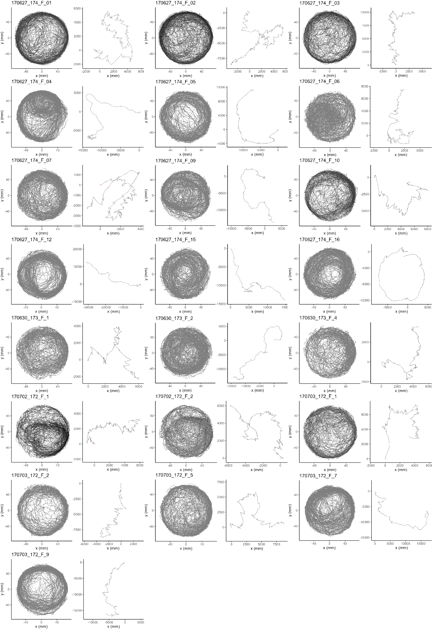

**Figure S1**. Original and unwrapped trajectories of single females.

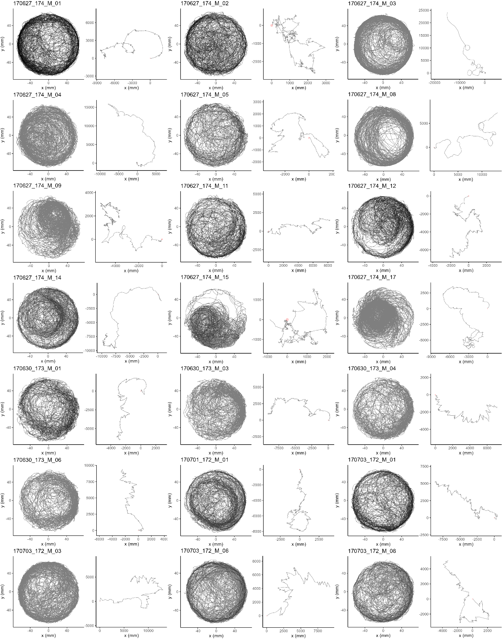

**Figure S2**. Original and unwrapped trajectories of single males.

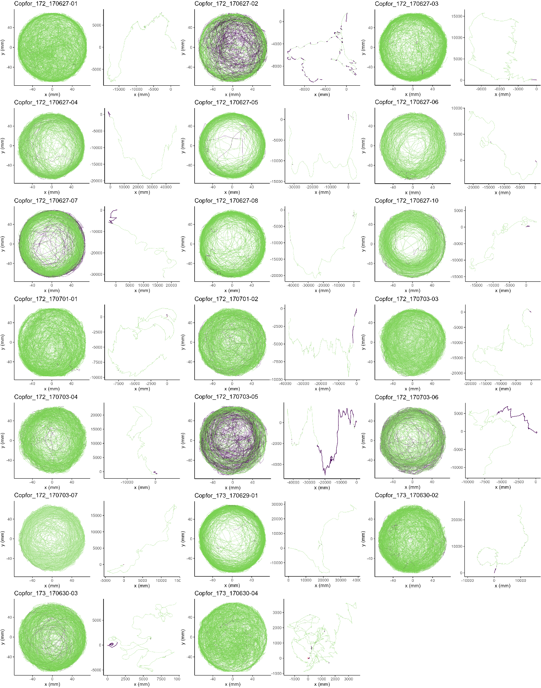

**Figure S3**. Original and unwrapped trajectories of tandem running pairs. Green is for tandem running, while purple is for separation.

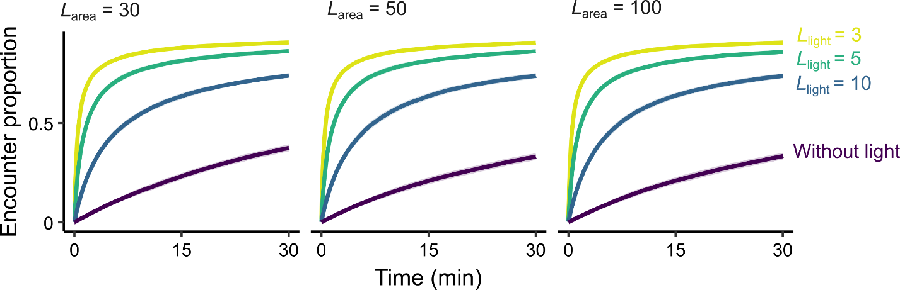

**Figure S4**. The results of the sensitivity analysis of the parameters *L*area and *L*light when *n* = 1,000.